WELCOME!
We are looking forward to a wonderful 2021-2022 school year!

Important Dates:

Registration Meeting: Spring 2022, Date to be determined
- meet current board of directors
- meet teachers and learn about what a day a play school looks like!
- learn about summer volunteer positions
- vote in new Board of Directors for 2021-2022

Wednesday September 8, 2021: first day of school - 4AM and 4PM

Thursday, September 9, 2021: first day of school - 3AM and 3/4PM

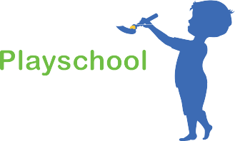
Wednesday, September 22, 2021: Annual General Meeting

- vote on any necessary Bylaw Changes
- re-introduction of teachers and new Board of Directors
- Volunteer Positions (out of class) assigned

Attached is a list of documents to help you get ready for next year. We look forward to seeing everyone! If you have any questions please contact us through our Website or email at info@chestermereplayschool.com

Attached Documents:
1. School Supply List
2. CRCA Membership form
3. Criminal Record & Vulnerable Sector Check Form
4. Bylaws
5. Handbook
6. Teacher Information Sheet

